Concord Home Sales

**1880 DOVER ROAD @ THE EPSOM CIRCLE, EPSOM, NH 03234**

**PH 603.736.4677 ConcordHomesNH.com FX 603.736.4679**

**\*\*\*\*\*\*\*\*\*\*\*\*\*\*\*\*\*\*\*\*\*\*\*\*\*\*\*\*\*\*\*\*\*\*\*\*\*\*\*\*\*\*\*\*\*\*\*\*\*\*\*\*\*\*\*\*\*\*\*\*\*\*\*\*\*\*\***

***Special Pricing for August, 2014***

**Home just needs to be under deposit for this special. Delivery can be within 6 months!**

***C:\Users\1880 Dover Rd\AppData\Local\Microsoft\Windows\Temporary Internet Files\Content.IE5\TXNPXSSH\MC900434465[1].wmf***

***Special***

COMING SOON!!!

*Added ½ bath*

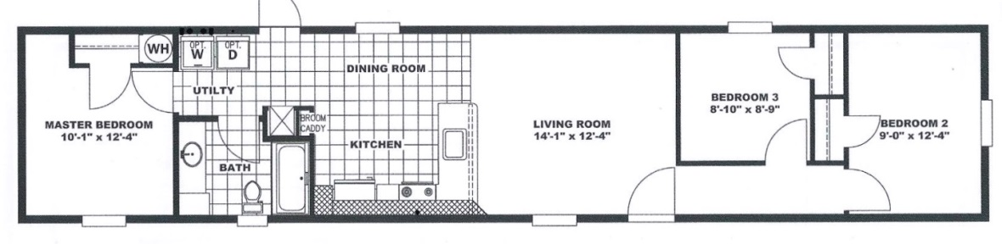

**Inspiration Alder**

***$37,295 BASE***

INS7014-66

**880 Sq. ft.**

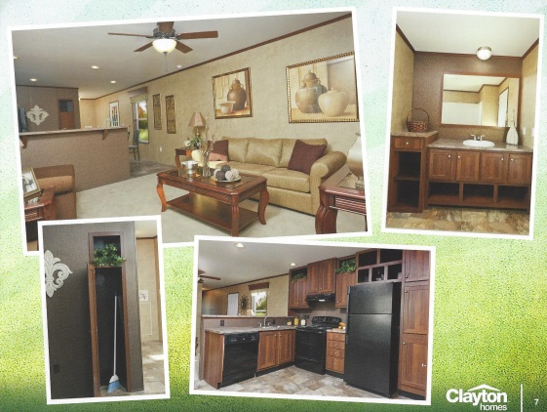**Display home options include:**

Additional Shutters 150.00

Half Bath (1 & ½ total) 599.00

Finished Drywall (save $3,395 in August) N/C

Add window in Ba 215.00

Add window in Living 305.00

Den & Larger Bd 2 Closet 300.00

Classic Inspiration Package (save $500 in August) 495.00

Gas Furnace Double Bowl Kitchen Sink

Can Lights Ext Faucet

R-30 ceiling 1 Pc Tub

100 amp service Shut-Off Valves

Foyer lino 9-Lt Rear Door

PJ & TV Hunter Ceiling Fan

**As displayed** this home is $37,295 plus $5,959.00 = **$43,254.00**

AUGUST SPECIAL $39,359w/ ALL OPTIONS

**All special pricing includes:**

**All Standard Features, Choice of New 2014 Color Options, Delivery to Lot Ready Site, Block and Level, Interior & Exterior Trim-Out of Home, Full Manufacturer’s Warranty**