Concord Home Sales
@ THE EPSOM CIRCLE

Welcome To Our Open Houses

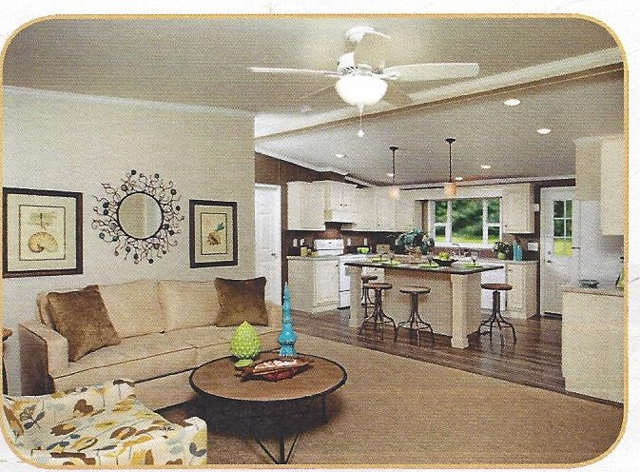

603-736-4677 ConcordHomesNH.com

EPSOM TRAFFIC CIRCLE, INTERSECTION OF RTS 28 AND 4/202/9
1880 DOVER ROAD, EPSOM, NH 03234

Serving All of New England

Inspiration
Series

MOST HOME FOR THE MONEY
GREAT NEW FLOORPLANS
AMAZING MODERN ACCENTS
BUILT-IN ENTERTAINMENT CENTER

LIMITED COLOR OPTIONS
LIMITED STRUCTURAL CHANGES

INSPIRATION SERIES
CONCORD HOMES BASE PRICING INCLUDES
Delivery to lot ready site, block and level, interior & exterior finish work of home

STANDARD HOME FEATURES:
36” Steel 6-Panel Front Door
Deadbolt Locks on Both Doors
30# Roof 16” OC w/R-30 Insulation
25 Year Asphalt Shingles
Iceguard at Eaves
2X6 walls 16”OC w/R-19 Insulation
2X6 Floor Joists over Recessed Steel Frame
Thermal Star Exterior Wall Sheathing
5/8 OSB Floor Decking
Vinyl Tilt-In Windows
Vinyl Dutch Lap Siding w/ Front Shutters
Smooth Finish Painted Drywall Ceilings
Ceiling Fan in Living Room*
Trim Throughout to Match Cabinet Choice
Hidden Cabinet Door Hinges
Cabinet Crown Moldings and Black Accents
Black Range Hood Shroud w/Vent & Light
Black Appliances 30” Elec Range & 18CF Fridge
Recessed Lights in Kitchen & Dining (6)*
Neutral Wall Panels w/ Choice of Accent Walls
Entertainment Center w/ TV Jack
Phone Jack*
Exterior Frost Free Faucet & Electrical Outlet*
Window Treatments
6-Panel White Interior Doors
Auto-Ignition Gas Furnace w/Dual Control*
Banjo Counter Top in Bath 2 w/ Step-Up Linen
34” Furniture Style Bath Vanities
Transom Bath Windows*
Smoke Detectors in Each Bedroom
200 Amp Electrical Service
Garden Tub/Shower in Master Bath

HOME OPTIONS:
This Series has limited options.

ON-SITE OPTIONS:
Slab w/ Tie-Down Anchors and Straps
Skirting, White Vinyl or Custom
Utility Connections
Full Foundation Sets Standard Features are Subject to Change Without Notice
CHECK FINAL ORDER!!!
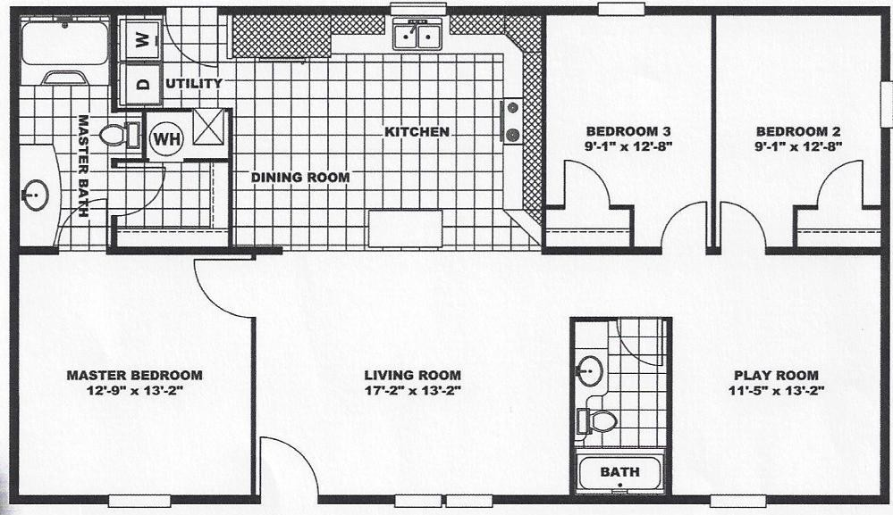
The Fraser $56,600
SOLD

956H4828-49 1280 Sq. ft.
Display home options include:
Additional window in Bath 1 215.00
Additional TV Jack 50.00

As displayed this home is $56,600 plus $265.00
$56,865.00

The Magnolia $55,500

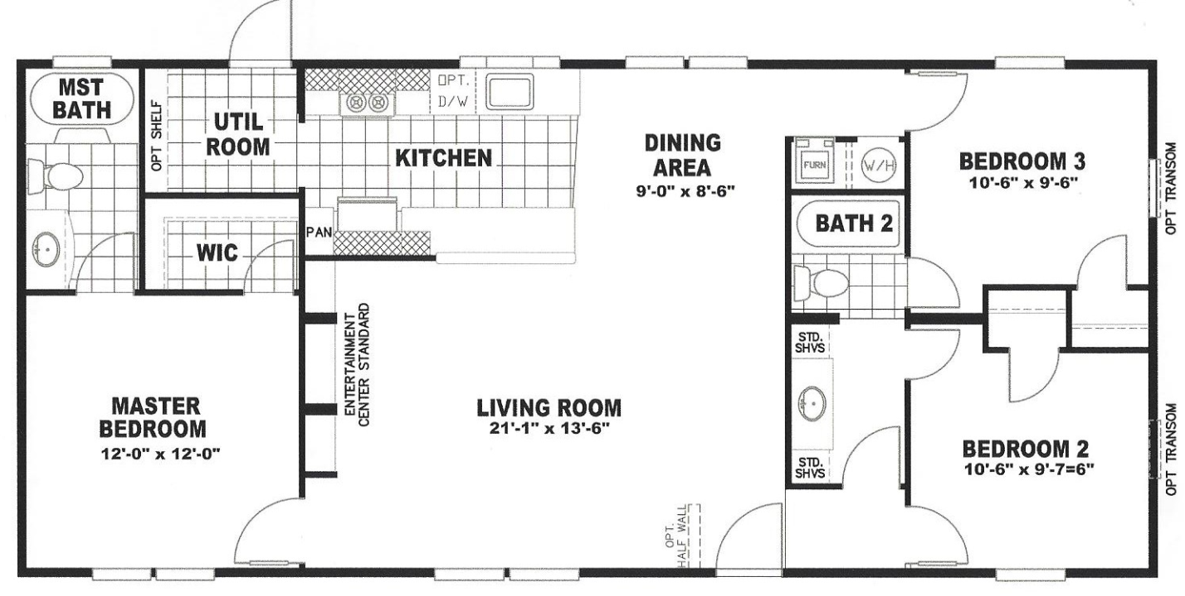

956H5024-50 1200 Sq. ft.
Display home options include:
Exterior treatment package 695.00
Additional window in bath 1 215.00
½ wall at entry w/ vinyl floor 145.00
Dishwasher 460.00
Additional TV jack 50.00
As displayed this home is $55,500 plus $1,565.00
$57,965.00
LOT MODEL Sold

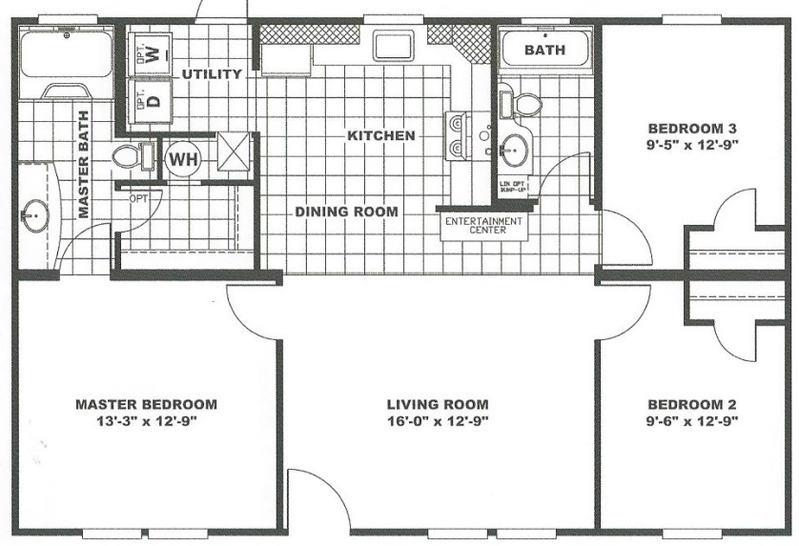
The Willow
28 X 40 - 1067 SF
Model 4028-40

3 bedroom
2 full baths
separate utility
built-in ent ctr
$52,745

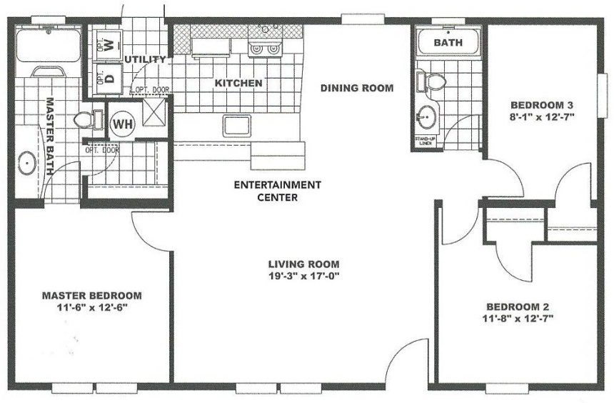
The Cypress
28 X 44 - 1173 SF
Model 4428-44

3 bedroom
2 full baths
Galley kitchenw/bar
$54,495

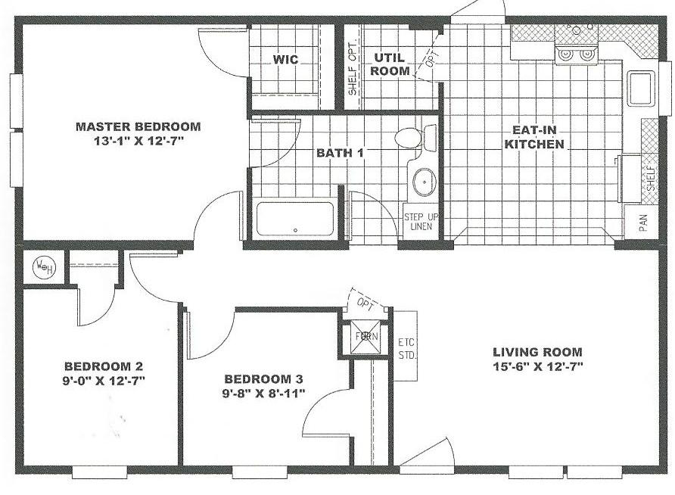
The Redwood
28 X 38 1013 SF
Model 3828-38

3 bedroom
1 full bath
$51,045

Optional Gable-End
Entrance Available
w/Full Endwall Porch
$6,900

The Douglas
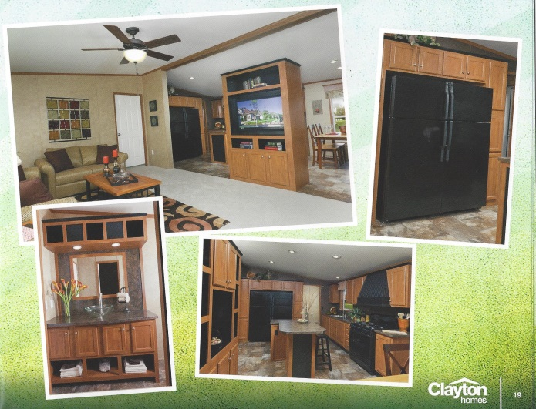
28 X 48 1280 SF Model 4838-48
3 bedroom, 2 full baths Country kitchen w/Double Fridge

$56,445
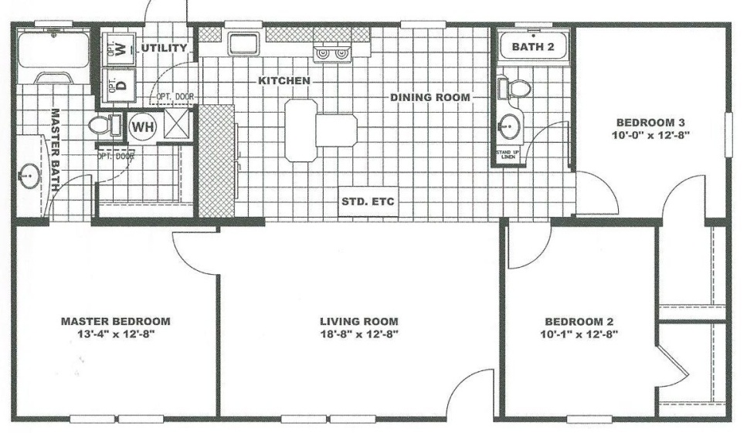

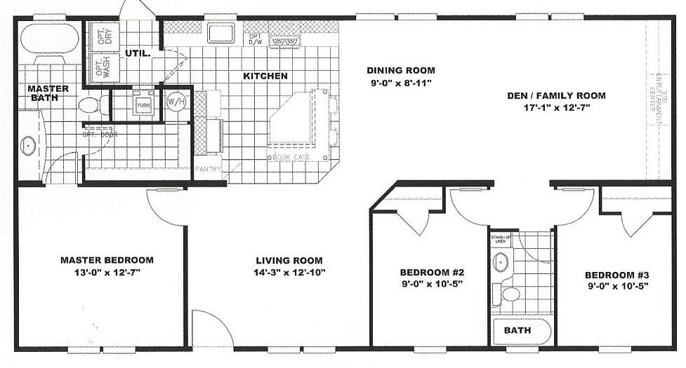

The Noble 3 bedroom 4 bedroom option
28 X 52 1013 SF 2 full baths in place of Family Rm
Model 3828-52 $57,895 add $1,200

Homestead
Series

BEST QUALITY ‘PACKAGED’ HOME
FINISHED DRYWALL THROUGHOUT
CHOICE OF PAINT COLOR

FULL ARRAY OF OPTIONS
NO ENGINEERING FEES

HOMESTEAD SERIES
CONCORD HOMES BASE PRICING INCLUDES
Delivery to lot ready site, block and level, interior & exterior finish work of home

STANDARD HOME FEATURES:
Smooth Finish Painted Drywall Walls Hardwood Kitchen and Bath Cabinets
Accent Paint in Specified Areas Kitchen Pantry w/ Built-In Microwave
Smooth Finish Painted Vaulted Ceilings Self Cleaning Range
20’ Roof Dormer (except end-entry model) Microwave/Hood Combo over Range
2X6 Exterior walls 16”OC w/R-19 Insulation 21 CF Refrigerator – Black Appliances
36” 6-Panel Fiberglass Front Door 2 Exterior Electrical Outlets w/ Weather Cover
Door Chime at Front Door 1 Exterior Frost Free Faucet
Dual Coach Lights at Front Door 6 Panel White Interior Doors
32” 6-Panel Fiberglass Rear Door Classic Profile White Trim
Porch Light at Rear Door Cornice Board w/Side Panel Curtains LR, DR, FR
Deadbolt Locks on Both Doors 1” Mini-Blinds Throughout
30# Roof 16” OC w/R-30 Insulation Cornice w/ Can Light over Master Bath Vanity
25 Year Fiberglass 3-Tab Shingles Hollywood Light Bar over Guest Bath Vanity
Iceguard at Eaves Picture Frame Vanity Mirrors
2X6 Floor Joists over Recessed Steel Frame Single Lever Faucets Throughout
7/16 OSB Sheathing w/Housewrap Shower Curtain Rod and Liner
19/32 T&G OSB Floor Decking Elongated Commodes in Both Baths
R-22 Fiberglass Floor Insulation Single Lever Faucets Throughout
Auto Ignite Gas Furnace w/dual control thermostat Faucet Sprayer in Kitchen
In Floor Perimeter Heat Ducts Black Composite Kitchen Sink
40 Gallon Electric Water Heater Fire Extinguisher Mounted under Kitchen Sink
200 Amp Electrical Service Ceramic Wall over Range
Low E Vinyl Tilt-In Windows w/Grids Accent Cornice over Range and Kitchen Window
Double 4” Vinyl Dutch Lap Siding -only over Range if Microwave/Hood Combo is Omitted
Raised Panel Shutters Front and Door Side Drawers over Doors in Kitchen Base Cabinets
Ceiling Fan w/ Light in Living Room 2 Adjustable Shelves in n Overhead Cabinets
Recessed Lights in Kitchen & Dining (6) Pot and Pan Roll-Out Shelf
Bedroom Ceiling Lights Bottom Trim on Kitchen Overhead Cabinets
Porcelain Sinks in Furniture Style Vanities Two Adjustable Shelves in Kitchen OH Cabinets
Water Shut-Offs Throughout Cabinet over Refrigerator
1 Piece Fiberglass Tub/Shower Center Shelves in Kitchen Base Cabinets
1 Piece Garden Tub/Shower in Master Bath Satin Nickel Cabinet Pulls
Built-In Entertainment Center w/ TV Jack High Pressure Laminate Counters
2 Phone Jacks & 1 Additional TV Jack Lighted Cornice over Master Bedroom Bed Area

HOME OPTIONS:
A complete array of options is available for this series. SOME BASIC OPTIONS ARE LISTED ON PAGE 2

ON-SITE OPTIONS:
Slab w/ Tie-Down Anchors and Straps
Skirting, White Vinyl or Custom
Utility Connections
Full Foundation Sets Standard Features are Subject to Change Without Notice
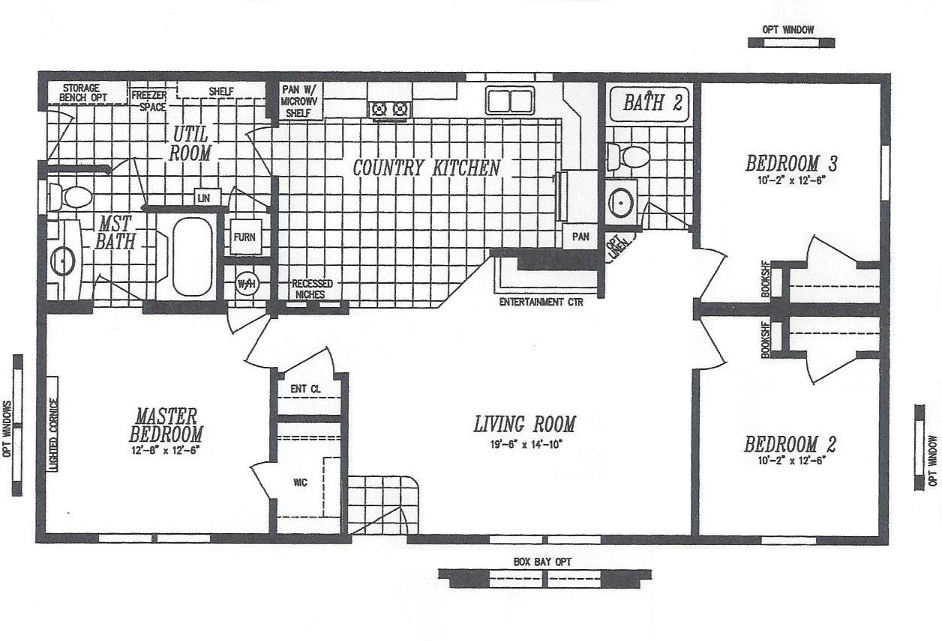
Concord Home Sales @ Epsom Circle 736-4677

The Homestead $67,700

ML4828-410 1280 Sq. ft.
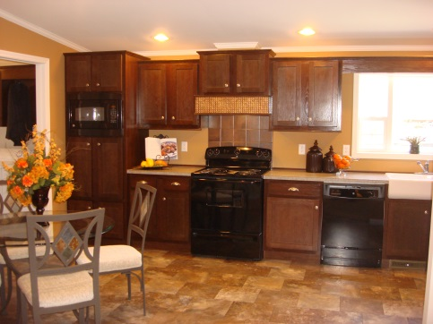
Display home options include:

White ‘apron’ Kitchen Sink 175.00
Espresso Cabinets 300.00
Dishwasher 460.00
Microwave 475.00
Better Living Package 1,295.00

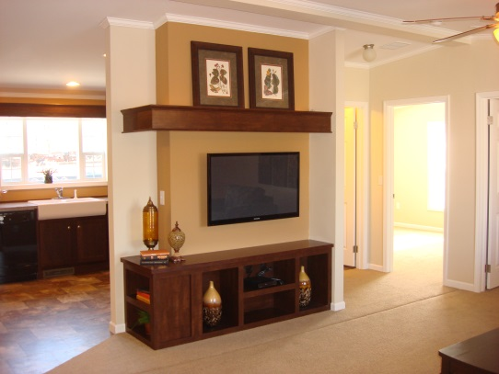

As displayed this home is $67,700 plus $2,705.00
$70,405.00
LOT MODEL SOLD

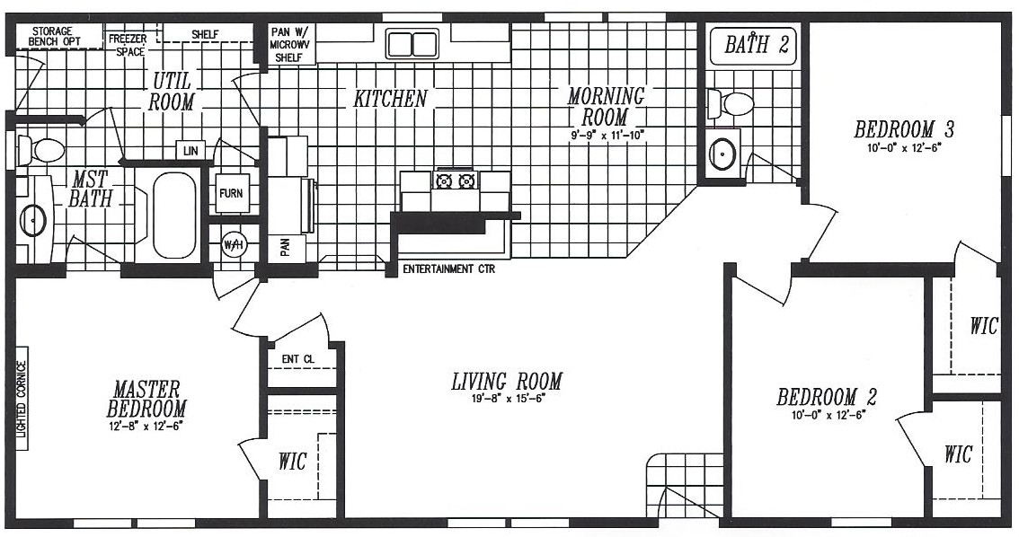
Homestead
28 X 52 1387 SF
Model 405

3 bedroom
2 full baths
Many built-ins
$69,900

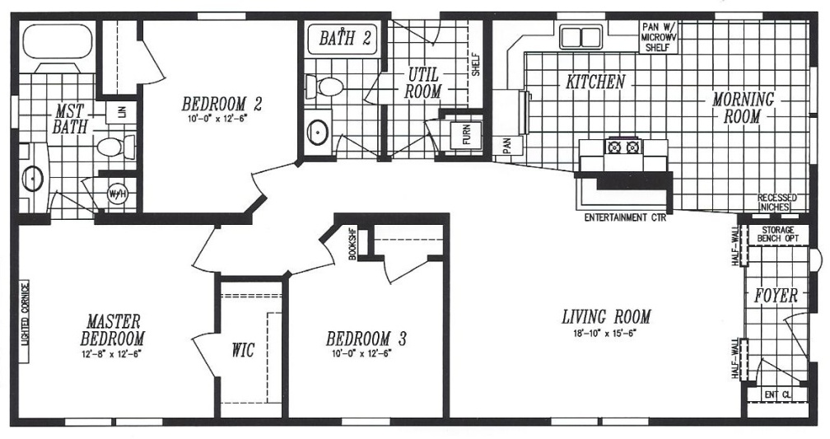

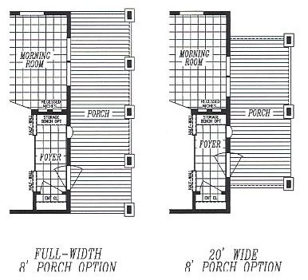

Homestead 3 bedroom Either Porch $5,995
28 X 52 1387 SF 2 full baths White Vinyl add $1,640
Model 508 $72,600 Mr. Wilson add 935
Need 5/12 roof w/ Mr. Wilson

Hearthside Package available on Any Homestead $6,995
see pg 2 of options for details

Homestead
28 X 56 1493 SF Model 363

3 bedroom
2 full baths
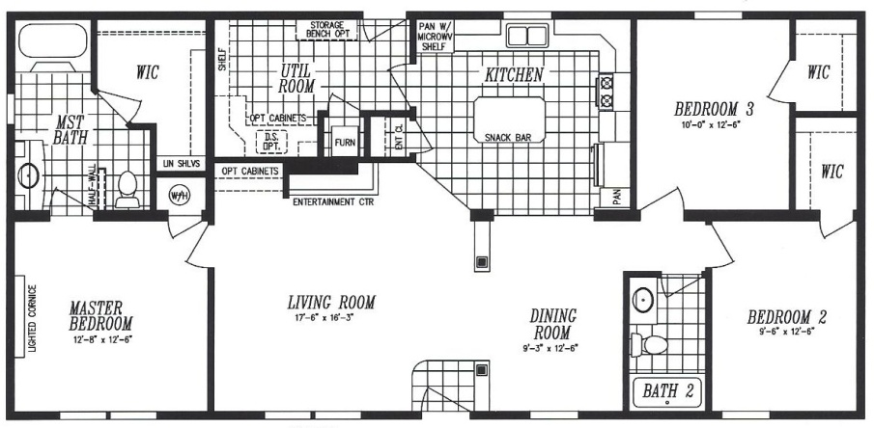
Many built-ins
$74,200

Ent Ctr Cabinets $495 UR Cabinets w/ Sink $785 Storage Bench $395

Homestead
28 X 56 1493 SF Model 68

3 bedroom
2 full baths
Many built-ins
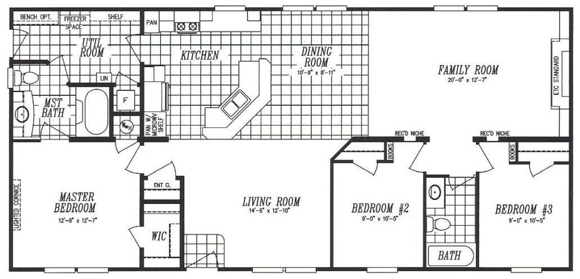
Family Room
$74,200

Fourth Bedroom Option $450
Better Living Package $1,295

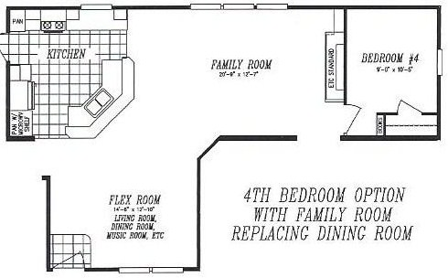

Hearthside Package available on Any Homestead $6,995 see pg 2 of options for details
Homestead
28 X 60 1600 SF Model 600

3 bedroom
2 full baths
Family Room
Many built-ins
$75,600
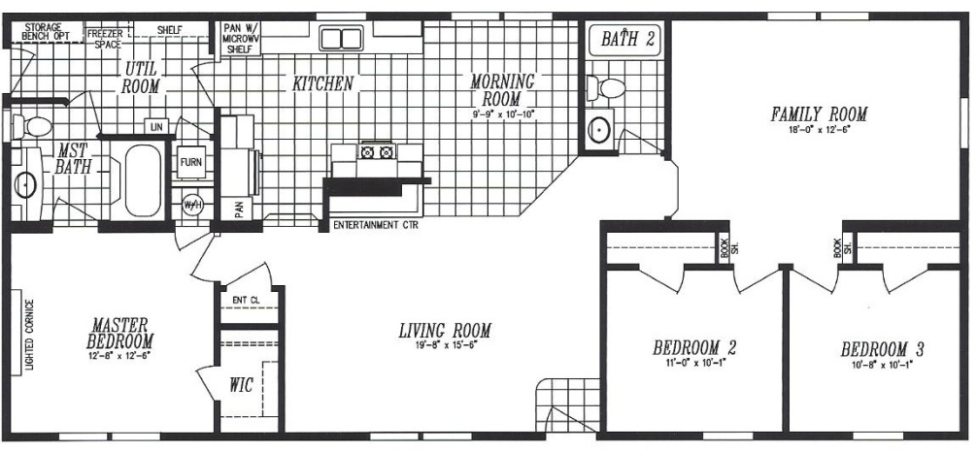

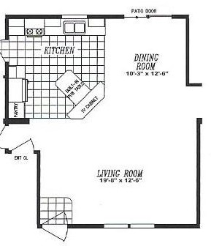

Alternate kitchen w/
Pub Table and Sliding
Glass Door
w/Alternate Front Entry
$950

Homestead
28 X 64 1706 SF
Model 69

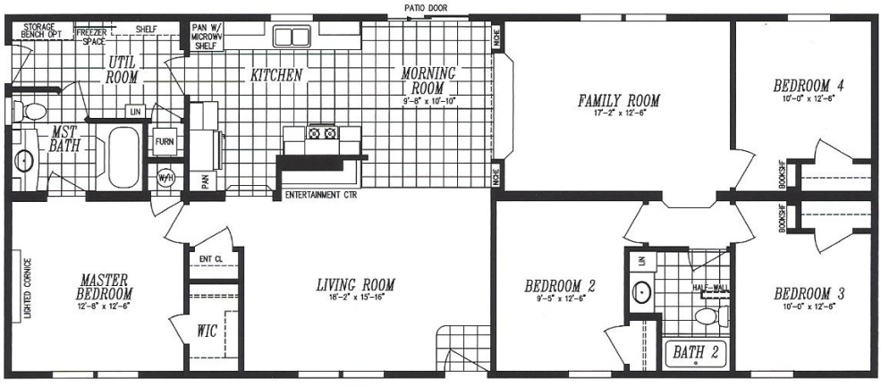
4 bedroom
2 full baths
Family Room
Many built-ins
$79,200

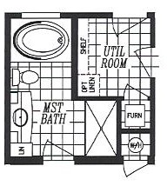
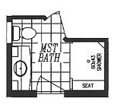
Deluxe Master Bath Options

Soaker Tub Walk-In Shower
w/ 60”Shower w/ Seat
$1,395 $595

New Horizon
Series

BEST SERIES TO CUSTOMIZE
WIDE ARRAY OF FLOORPLANS
NEAR LIMITLESS OPTIONS

PAY FOR ONLY
WHAT IS IMPORTANT TO YOU

NEW HORIZON SERIES
CONCORD HOMES BASE PRICING INCLUDES
Delivery to lot ready site, block and level, interior & exterior finish work of home

STANDARD HOME FEATURES:
36” Fiberglass 6-Panel Front Door Auto-Ignition Gas Furnace w/Dual Control
32” Cottage Rear Door w/ Exterior Light 200 Amp Electrical Service
Deadbolt Locks on Both Doors Smoke Detectors in Each Bedroom
30# Roof 16” OC w/R-30 Insulation Thermal Sheathing on Sidewalls
3-Tab Fiberglass Shingles 7/16 OSB w/Windwrap on Gable Ends
Iceguard at Eaves Vinyl Dutch Lap Siding w/ Front Shutters
2X6 walls 16”OC w/R-19 Insulation 2X6 Floor Joists, 5/8 OSB T&G Floor Decking
Dual Glazed Vinyl Windows – Low E Glass, No Grids 30 Gallon Electric Water Heater w/Drip Pan
90” Vaulted Smooth Finish Painted Drywall Ceilings Plumb, Wire and Vent for Washer & Dryer
Trim Throughout to Match Cabinet Choice Furniture Style Vanities in Baths
Hidden Cabinet Door Hinges Framed Vanity Mirrors
Citi-Scape Kitchen Overhead Cabinets Acrylic Vanity Bowls
MDF Cabinets w/Brushed Nickel Pulls 35” High Bath Vanity Cabinets
Accent Cornices at Kitchen Window and Over Range Power Bathroom Vents
Fully Lined Cabinets w/Adjustable OH Shelf Whole House Water Shut Off
Full Center Shelves in Base Cabinets
Laminate Countertops and Backsplashes
Stainless Steel Sink w/High-Rise Faucets
Fire Extinguisher under Kitchen Sink
30” Range Hood w/Light & Ceramic Backsplash
30” Range & 18CF Fridge
Can Lights in Kitchen & Dining
Decorative Wall Panels w/ Accent Panels
2 Phone Jacks
Exterior Frost Free Faucet & Electrical Outlet
Cornice Board w/ Side Panels LR, DR, FR
1” Mini Blinds Throughout
Choice of Floor Vinyl and Moxie Carpet Colors
6-Panel White Interior Doors
Fiberglass Tubs/Showers
Ceiling Lights in Each Bedroom
Lighted Cornice in Master Bedroom

HOME OPTIONS:
A complete array of options is available for this series. SOME BASIC OPTIONS ARE LISTED ON PAGE 2

ON-SITE OPTIONS:
Slab w/ Tie-Down Anchors and Straps
Skirting, White Vinyl or Custom
Utility Connections
Full Foundation Sets Standard Features are Subject to Change Without Notice

Concord Home Sales @ Epsom Circle 736-4677

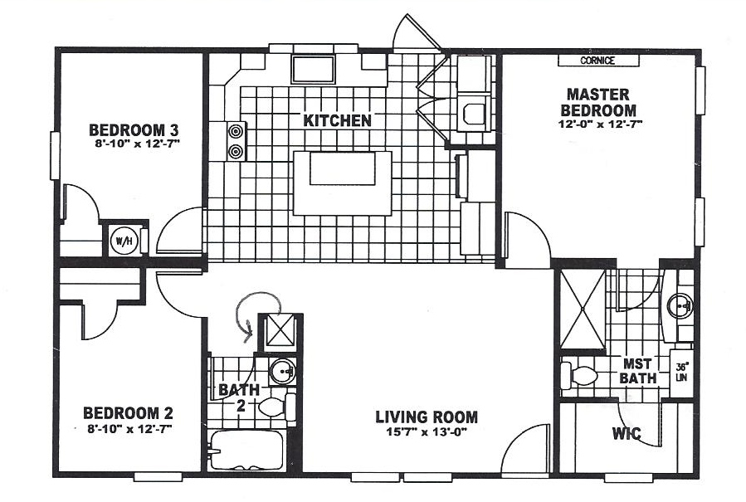

The New Horizon $56,000

4028-200 1067 Sq. ft.
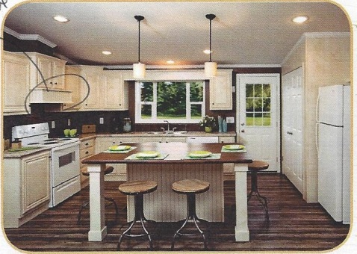
Display home options include:
10’ Dormer 535
9-Lite Rear Door n/c
Coastal Crème Kitchen (breakdown below) 1,105
Coastal Crème Cabinets 150
Coastal Crème UR Doors 350
Coastal Crème covered vent hood n/c
White Moulding Package 95
Pendant lights over Island 120
Ceramic Backsplash 95
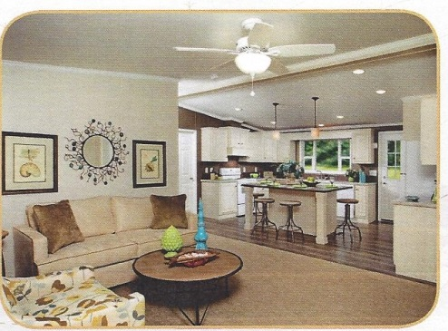
Crescent Edge on Counters 200
Premium Wilson Art Old Mill Oak island top 95
Whirlpool Dishwasher 460
Hunter Ceiling Fan 135
Accent Wall in MBR n/c
60” FG Shower IPO tub/shower 475
TV and PJ n/c

As displayed this home is $56,000 plus $2,710
$58,710.00*
*PLUS Upgraded Compass Siding 1,324

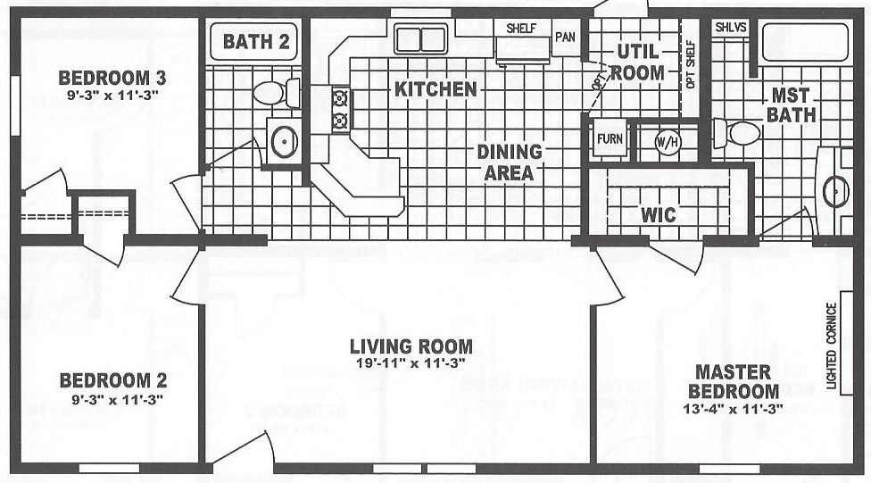
New Horizon
24 X 44 1056 SF

Model 301
3 bedroom
2 full baths
$55,800

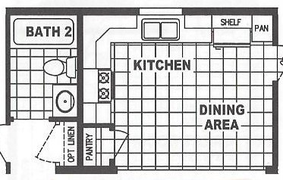
Alternate Kitchen Available
$500

New Horizon
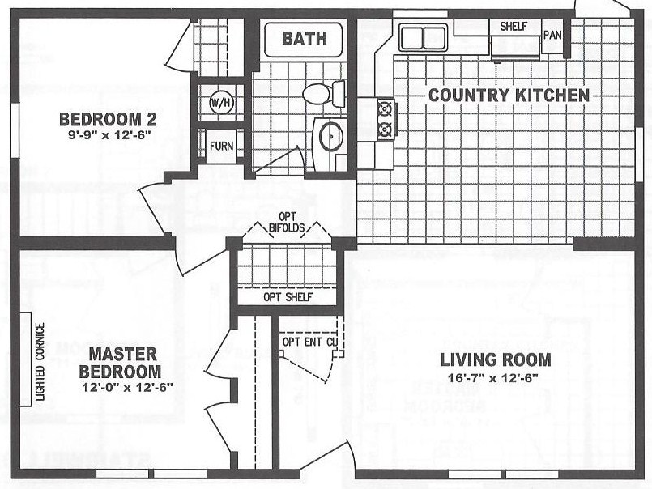
28 X 36 960 SF

Model 71
2 bedroom
1 full baths
$52,900
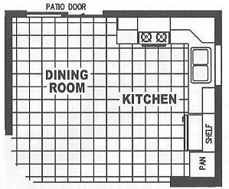 Alternate Kitchen Available - Add $950 for Slider

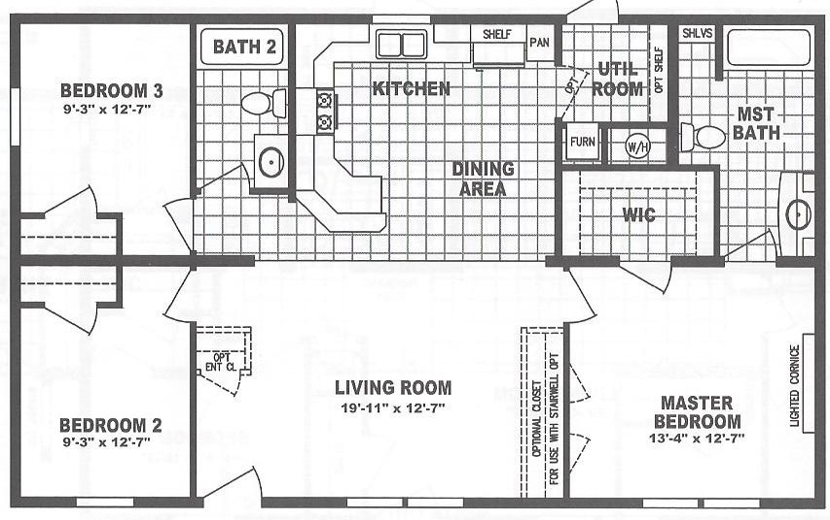
Horizon
28 X 44 1056 SF

Model 311
3 bedroom
2 full baths
$57,400
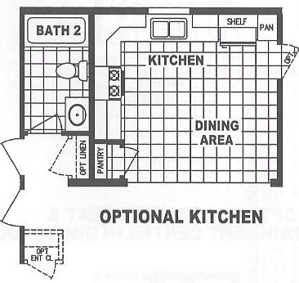
Alternate Kitchen Available $500

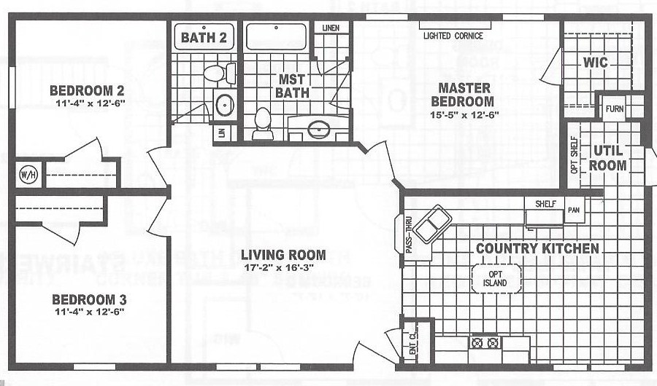
New Horizon
28 X 48 1280 SF

Model 515-1
3 bedroom
2 full baths
$59,600
New Horizon Model 407-1
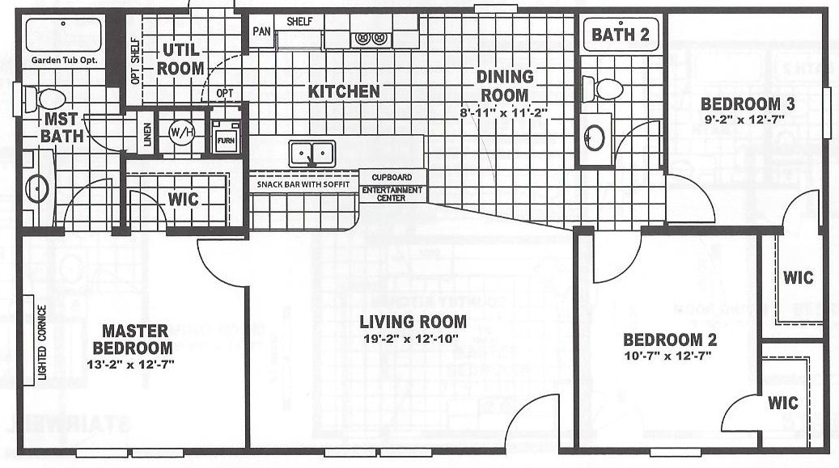
28 X 48 1280 SF 3 bedroom 2 full baths $59,600

New Horizon Model 83
28 X 54 1440 SF 3 bedroom 2 full baths $62,700

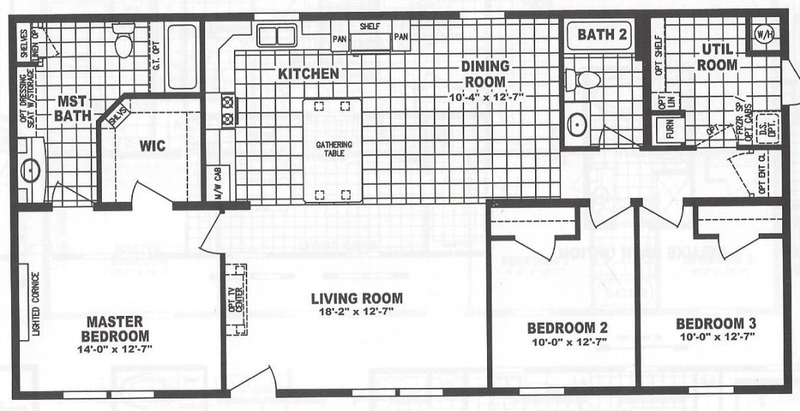

New Horizon Model 403
28 X 56 1493 SF

3 bedroom 2 full baths
$63,800
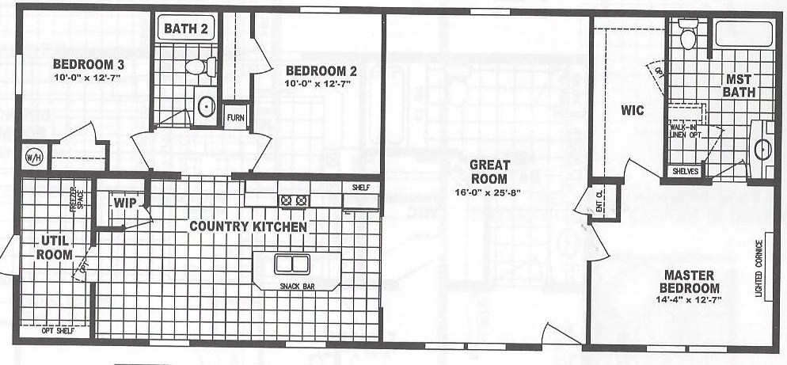

New Horizon
28 X 60 1600 SF

Model 2557-D Optional Kitchen Optional 4th Bedroom
3 bedroom $500 $500
2 full baths
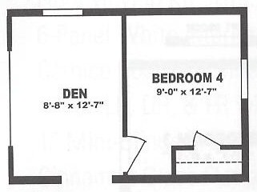
$70,600
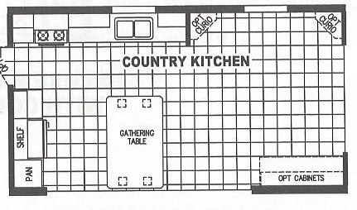
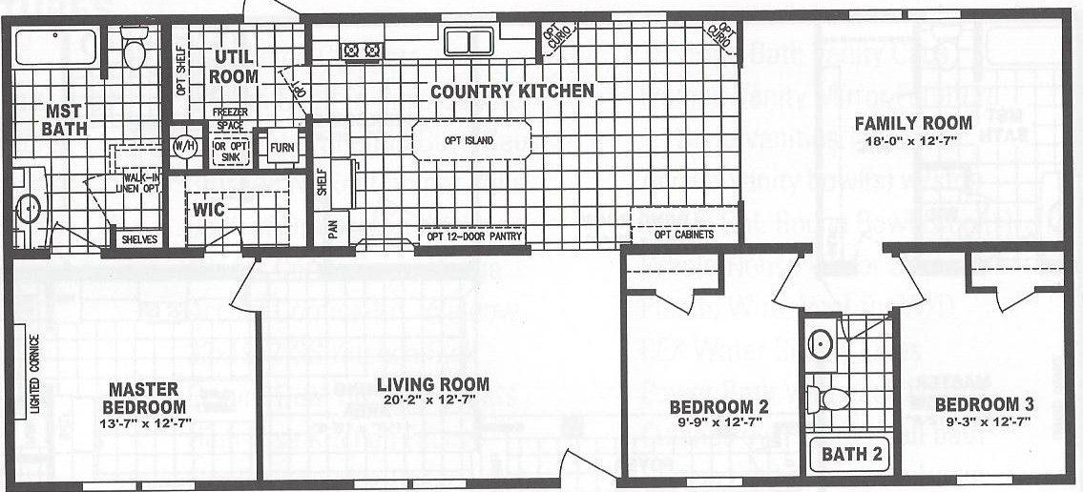

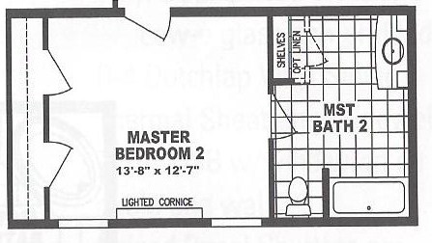
Optional 2nd Master Bedroom
w/ Master Bath
In Place Of Bath 2 and 3rd Bedroom
$850

Must Add Door from Family Room for Guest Bath

New Horizon
28 X 64 1706 SF

Model 323-1
3 bedroom
2 full baths
$76,100
